**MONGO DB**

**Overview:** MongoDB is a cross-platform, document oriented database that provides high performance, high availability, and easy scalability. MongoDB works on the concept of collection and document.

**Working Flowchart**

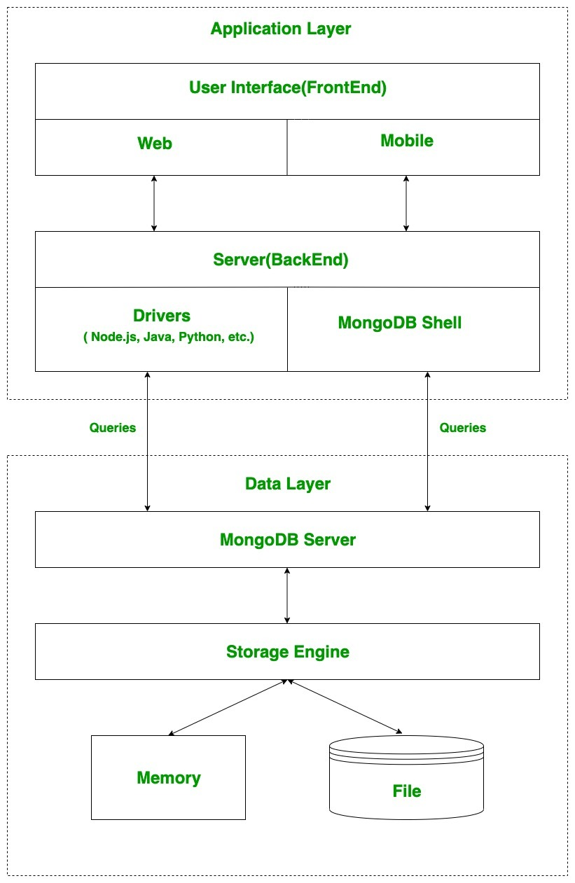

**Install MongoDB on Windows**

To install MongoDB on Windows, first download the latest release of MongoDB from http://www.mongodb.org/downloads.To get your Windows version, open command prompt and execute the following command.

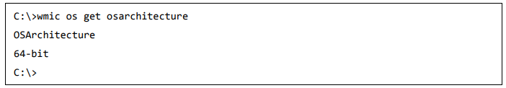

Now extract your downloaded file to c:\ drive or any other location. Make sure the name of the extracted folder is mongodb-win32-i386-[version] or mongodb-win32-x86_64-[version]. Next, open the command prompt and run the following command.

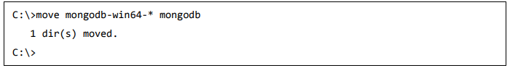

In case you have extracted the MongoDB at different location, then go to that path by using command cd FOLDER/DIR and now run the above given process.

MongoDB requires a data folder to store its files. The default location for the MongoDB data directory is c:\data\db. Execute the following command sequence.



If you have to install the MongoDB at a different location, then you need to specify an alternate path for \data\db by setting the path dbpath in mongod.exe.

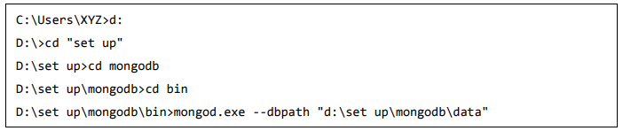

Now to run the MongoDB, you need to open another command prompt and issue the following command.

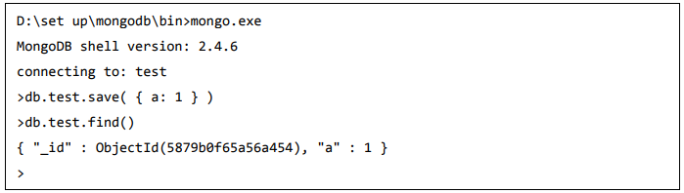

This will show that MongoDB is installed and run successfully. Next time when you run MongoDB, you need to issue only commands.

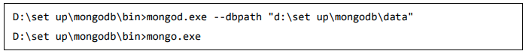

**Insert**

In MongoDB, the**db.collection.insert()** method is used to add or insert new documents into a collection in your database.

**upsert**

There are also two methods **db.collection.update()** method and **db.collection.save()** method used for the same purpose. These methods add new documents through an operation called **upsert**.

**Upsert** is an operation that performs either an update of an existing document or an insert of a new document if the document to modify does not exist.

**MongoDB Delete documents**

In MongoDB, the **db.collection.remove()** method is used to delete documents from a collection. The remove() method works on two parameters.

**1. Deletion criteria:** With the use of its syntax you can remove the documents from the collection.

**2. JustOne:** It removes only one document when set to true or 1.

**Check the inserted documents**

If the insertion is successful, we can view the inserted document by the following query.

**db.collections.find()**

**MongoDB insert multiple documents**

If we want to insert multiple documents in a collection ,we have to pass an array of documents to the **db.collection.insert()** method.

**Aggregate**

**$group**

Group is used to group together items into required subsets on a particular criterion.  We can also use groups to perform operations across a common field in all documents, such as calculating the sum of a set of transactions and counting documents.

**$match**

Filters the documents to pass only the documents that match the specified condition(s) to the next pipeline stage.

**MONGODB QUERIES**

1. Basic syntax of to create a database **use DATABASENAME** statement is as follows:

* use newdb



------------------------------------------------------------------------------------------------------------------------------------------

1. To check your currently selected database, use the command **db**

* db



------------------------------------------------------------------------------------------------------------------------------------------

1. To insert document, **db.collectionname.insert({})** command is used

* db.weather.insert({status ; “sunny”})



------------------------------------------------------------------------------------------------------------------------------------------

1. To check the databases list, use the command **show dbs**

* show dbs

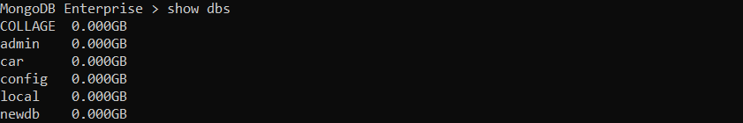

------------------------------------------------------------------------------------------------------------------------------------------

1. MongoDB **db.dropDatabase()** command is used to drop a existing database

* db.dropDatabase() //Collage database has been deleted

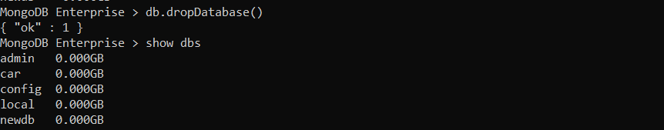

------------------------------------------------------------------------------------------------------------------------------------------

1. MongoDB **db.createCollection(name, options)** is used to create collection.

* db.createCollection(“Food Items”)



------------------------------------------------------------------------------------------------------------------------------------------

1. check the created collection by using the command **show collections**.

* show collections

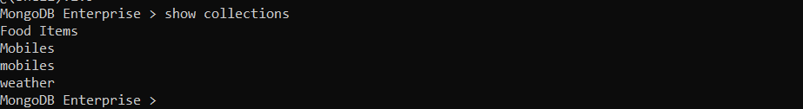

------------------------------------------------------------------------------------------------------------------------------------------

1. Insert multiple documents **Var arrayname = [] , db.collectioname.insert(arrayname)**

* Creating an array
* Var details = [{}];



* db.company.insert(details)

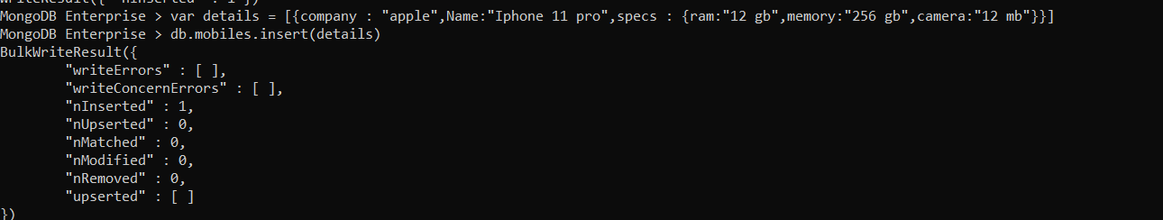

------------------------------------------------------------------------------------------------------------------------------------------

* Using bulk()
* var bulk = db.javatpoint.initializeUnorderedBulkOp();
  + bulk.insert({})



* + bulk.execute

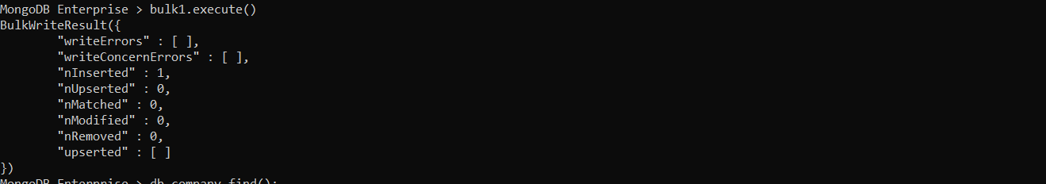

------------------------------------------------------------------------------------------------------------------------------------------

1. Update documents using **update()** command

* Db.company.update({Name : “Ford”},{$set:{Name:”Benz”}})



------------------------------------------------------------------------------------------------------------------------------------------

1. Find documents in collection **find**() cmd

* db.company.find()



**AGGREGATE FUNCTIONS**

1. $match : Retrive data based on matching conditions

* db.company. { $match: { "zip": 90210 }}

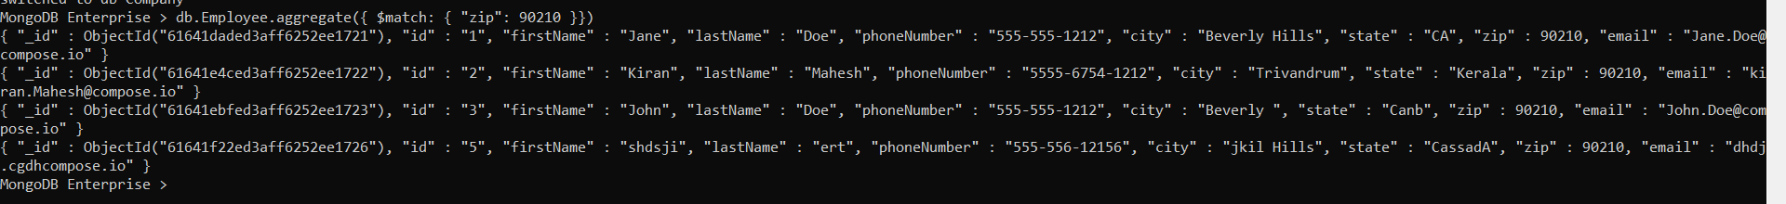

------------------------------------------------------------------------------------------------------------------------------------------

1. $group

* db.Employee.aggregate({ $group: {_id:"firstname",fieldname:{$avg:"$zip"} }})



------------------------------------------------------------------------------------------------------------------------------------------